Aloha!
We welcome all who are interested in learning how to worship God through hula. Our mission is to share the Love of Jesus Christ with everyone.

One of God’s gifts to the Hawaiian people is Hula. Our desire is to honor Hula as its own unique language. The basics of Hula are taught in all classes.

We also desire to perpetuate God’s original intention for hula which is to further His Aloha.

We hope that you will experience God’s Aloha as you join us in Hula.

Aloha Pumehana!

Kahu Daniel and Yolanda Kikawa

Hula Class Times
Mondays

Level One (Basics)
5:00-6:00pm

Level Two
6:05-7:30pm

Classes will start on time

No classes will be held on holidays

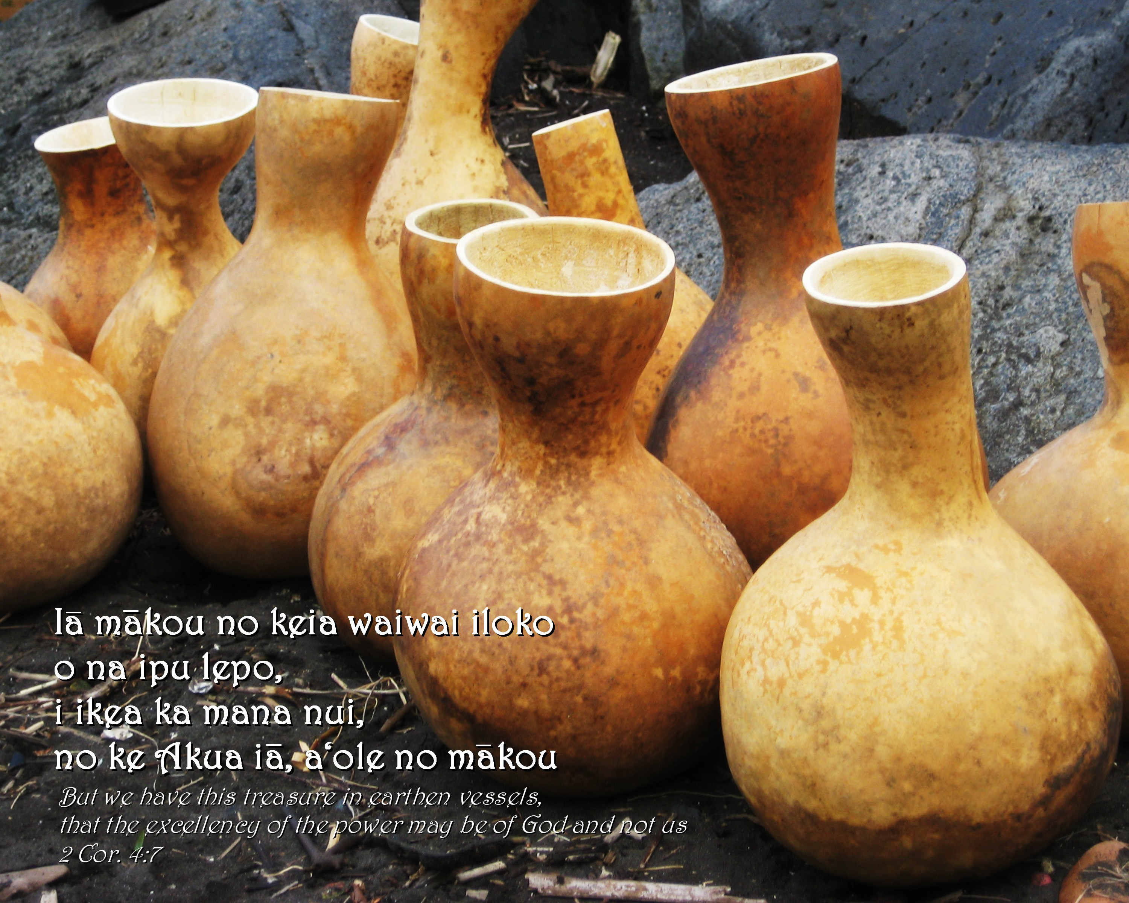
Hula
Ministry
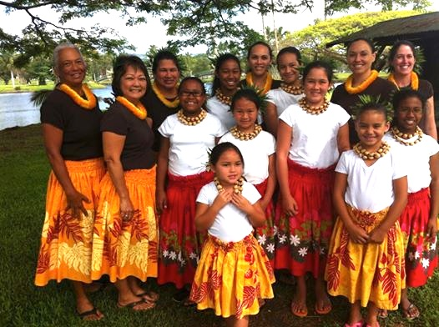
Hilo Missionary
Church
1044 Komohana Street
Phone: 959-9211

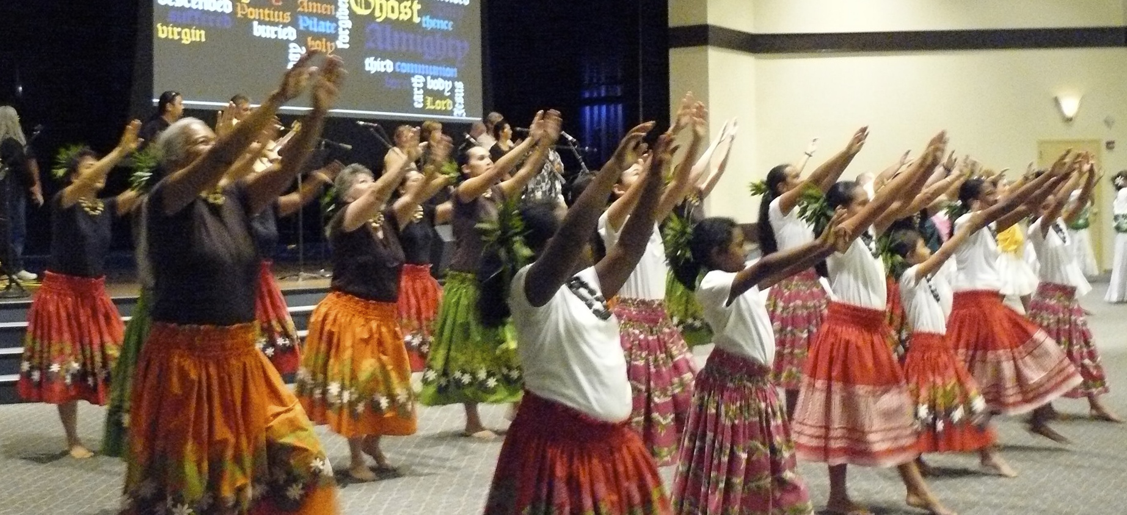
Purpose:
“To raise up, equip, and disciple God’s Worshippers (warriors)
In Hula.”

Vision:
“Let them praise His name in the dance; let them sing praises . . .”
Psalm 149:3 KJV

“My prayer is to come humbly before you as an earthen vessel to share your Aloha with the world in worship through Hula, the wonderful expression you gave to Hawai`i.”

James 1:17, Psalm 149:3,
2 Corinthians 4:7

Mission:
“To develop relationships with each other and with God as worshippers through Hula.”

Love God, Love People

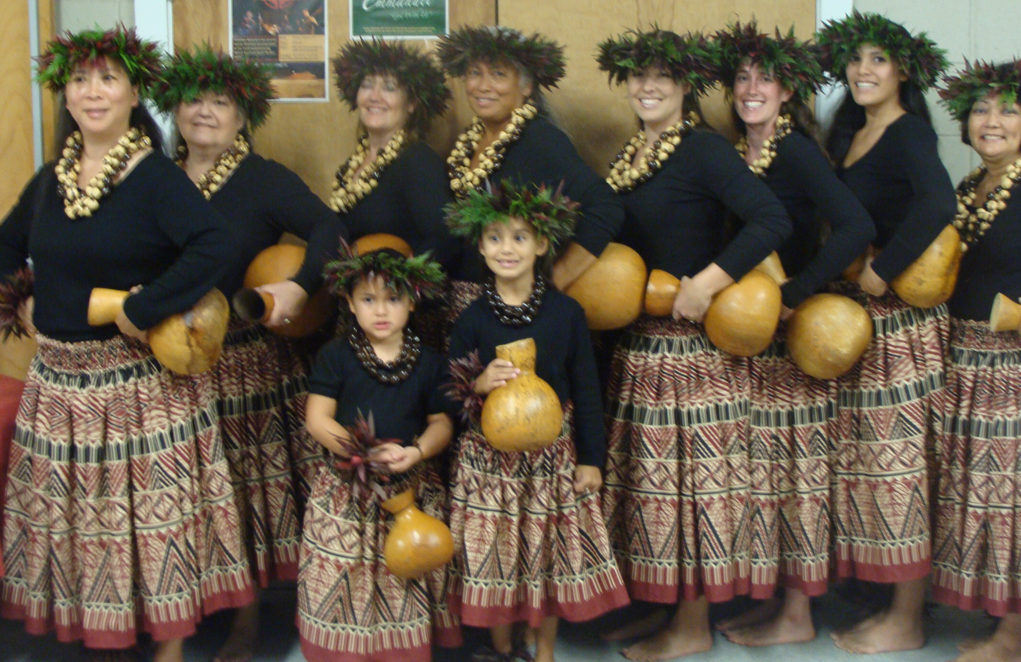

“But we have this treasure in earthen vessels, that the excellence of the power may be of God and not of us.” 2 Corinthians 4:7
Class Expectations
- Arrive 10 minutes before class to get your hula pa`u, drink water, use the restroom and to help set up class.
- Have hula folder and pencil, hula implements, water bottle.
- Honor and respect the Hula teacher, each other and class time.
- Remain in class once class starts.
- Silence all cell phones.
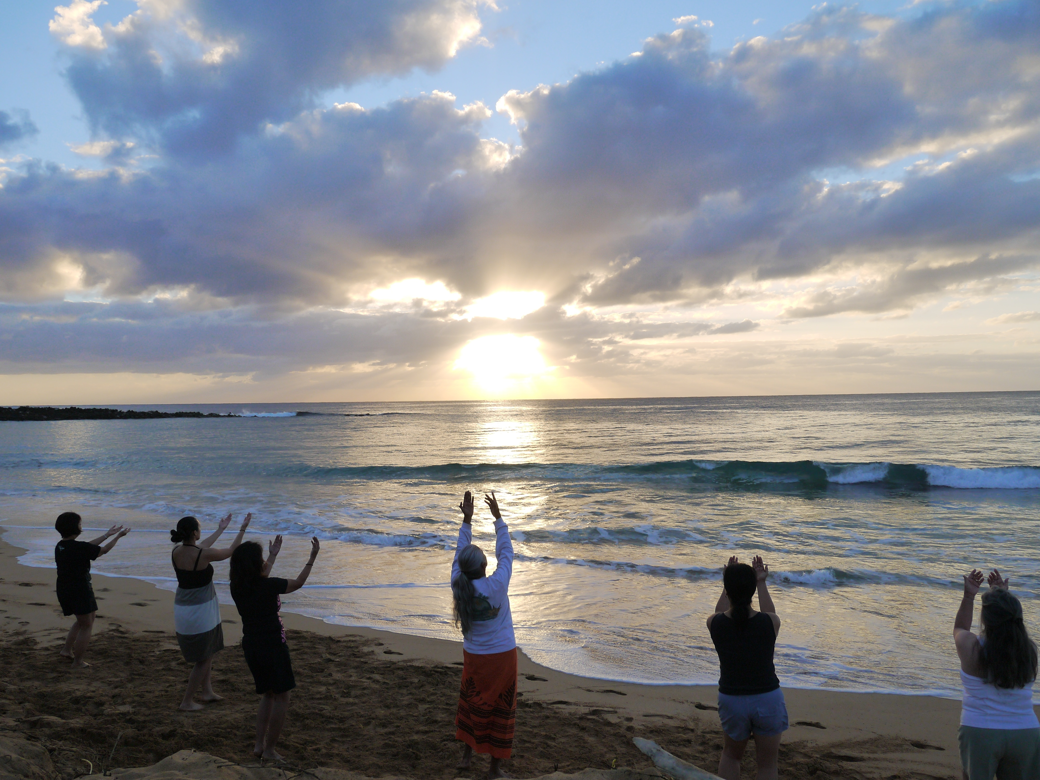
To worship God with excellence, we encourage all participants to practice throughout the week.

Knowing the lyrics and mana`o (their meaning) will help in understanding the motions and steps.

Read God’s Word and reflect on His message to you.

Practice!

